**What is .env file?**

A **.env file** is a configuration file used to define environment variables for an application. It typically contains key-value pairs that represent settings or sensitive information, such as database connection strings, API keys, or application secrets. This approach helps keep sensitive data out of the source code.

**Why Use a .env File?**

1. **Security**:
   * Avoids hardcoding sensitive information (e.g., passwords, API keys) in the codebase.
   * Keeps secrets out of version control systems like Git.
2. **Configuration Management**:
   * Makes it easy to switch between environments (development, staging, production) by using different .env files.
3. **Separation of Concerns**:
   * Keeps configuration data separate from the application's code.

How to Use a .env File in Node.js:

Step 1:

1. Install dotenv Package:

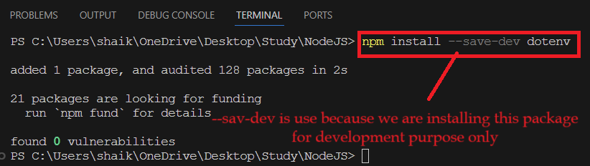

1. Create .env file on project root folder.

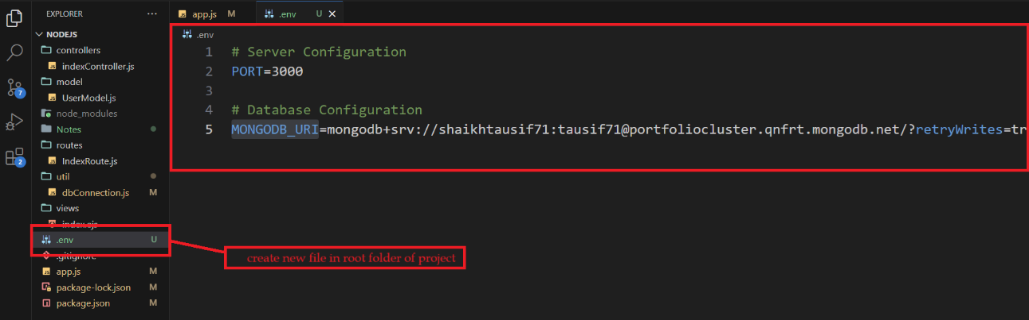

1. To use added Environment variable in application, suppose we added MONGODB_URI in dbConnection.js if we want to use that variable we first need to import dotenv package then call .config method as shown in below screenshot. After calling .config function all added environment variable we will access those variable by using process.env.[variable_name] as shown below.

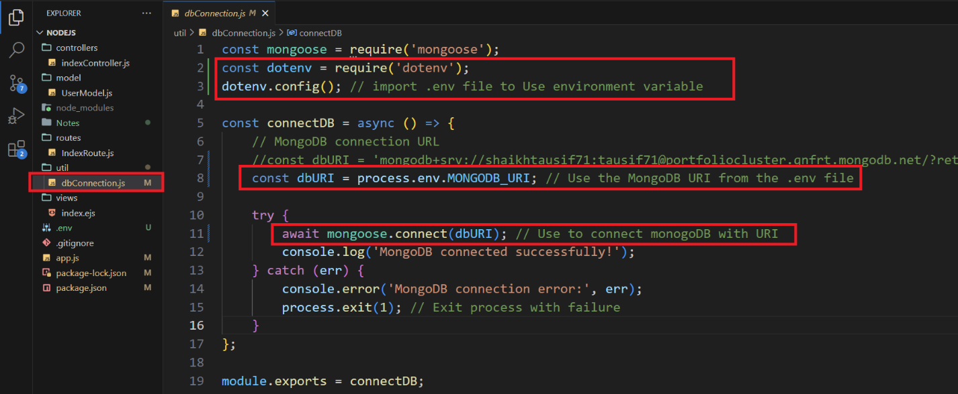

We can also use PORT_NO in app.js from .env file

